Constants
Constants are designed to store information that rarely or never changes. For example, our company sells goods online and delivers goods to customers through delivery services. However, customers have the opportunity to pick up the goods on their own, for this, one warehouse is used (despite the fact that the company has several warehouses), let's call it "pickup warehouse". If the delivery method "pickup" is specified, when registering a sale, it is necessary that the "pickup warehouse" be used as the sales warehouse. So that the user does not waste his time on checking the correctness of filling, we can automatically fill in the sales warehouse with the default value when choosing the "pickup" delivery method. Over time, it may become necessary to change the default value (for example, a warehouse was previously rented, and later another warehouse was purchased), then we can change the value of the constant and continue working without wasting time.
The platform automatically generates a form for working with the constant value. In addition, the developer can create a common form (“Common branch” - Common forms) with the “Constants form” type to work with certain constants. In order to allow the user to work with the value of a constant from an interface without creating a common form, the “Include in the command interface” property must be enabled. The “Default form” property is used so that when opening a constant for editing, the form specified in this property is used instead of the automatically generated one.
Let's create the "Default company" constant, the value of which will be used for filling in new documents during creation. To show what the properties of the constant affect, first include it in the subsystem and leave the “Include in the command interface” property enabled
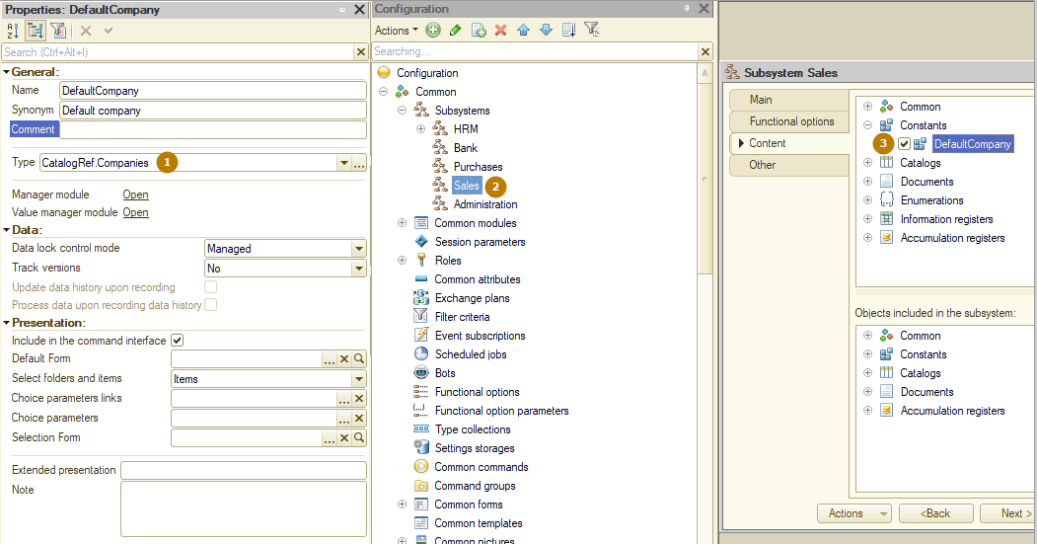
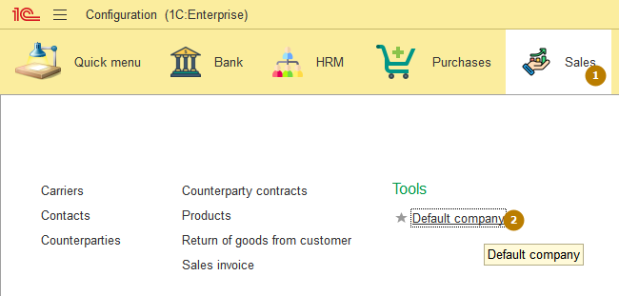
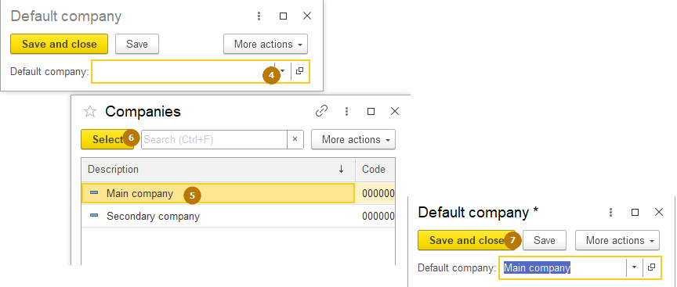
Now let's create a common form with the type “Сonstants form”,
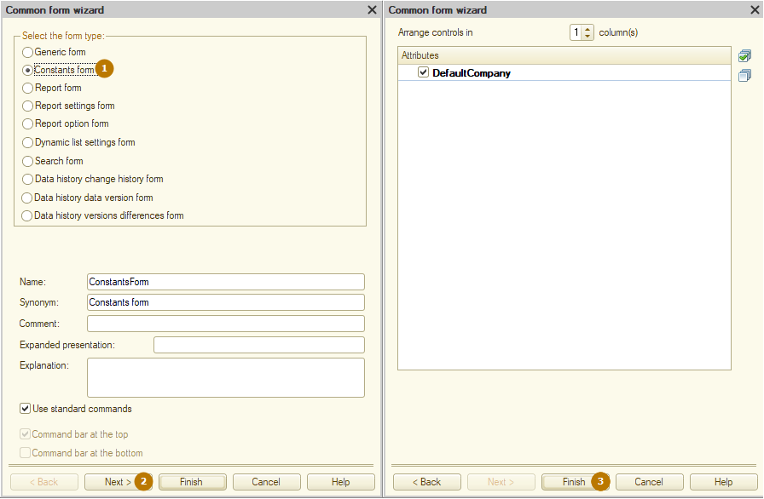
add it to the Sales subsystem,
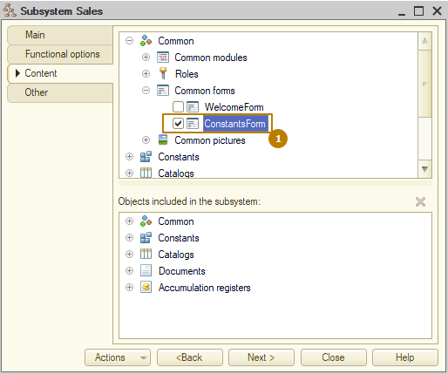
update the configuration and run the infobase in Enterprise mode.
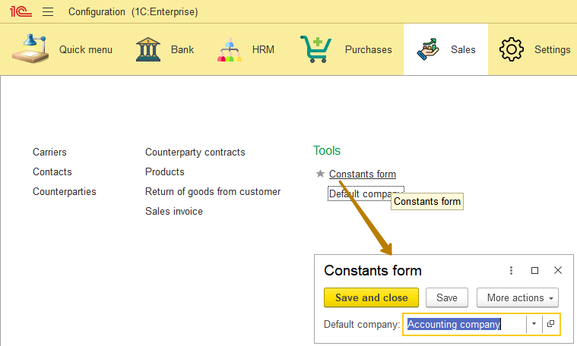
We can see that the opened form contains the value of the "Default Company" constant. It turns out that we can combine constants in forms, grouping them according to their purpose. Let's create a "Default bank account" constant and add it to the Constants form (also include a new constant in the Sales subsystem).
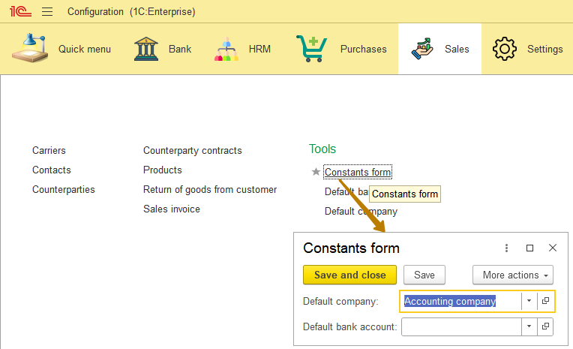 It can be noted that with such a form, it is no longer necessary to give the opportunity to open individual forms of constants. Let's remove them from the interface, for this I will disable the "Include in the command interface" property. I'll also give a more meaningful name to the common form, let’s call it "Default values":
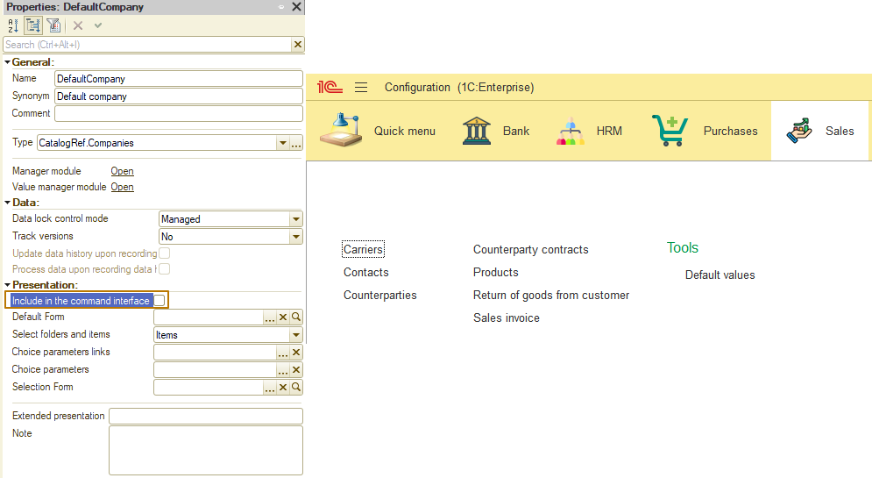
When working with constants from a code, you can get and set the value of a constant. To set the value use the Set() procedure, and to get the value use the Get() function of the constant manager, for example:
// Setting the value
Constants.MainSignatory.Set("John Doe");
// Getting the value
DefaultCompany = Constants.DefaultCompany.Get();
Let's implement automatic filling of the company and bank account in the Sales invoice document. To do this, I need to create a handler for the Filling event in the document object module and add code there for assigning a constant values to the document attributes.
Procedure Filling(FillingData, FillingText, StandardProcessing)

Company = Constants.DefaultCompany.Get();
BankAccount = Constants.DefaultBankAccount.Get();

EndProcedure
Note: It is not recommended to use constants for constantly changing values, such as:
- temporary resource access tokens
- calculated numerical values, recalculation of which is carried out regularly
- other values that are known in advance to change with a certain periodicity.
Document journals
Document journals are intended primarily for visual grouping of documents of different types when viewed. In 1C:Enterprise you can create several “Document journal” metadata objects in the configuration. The metadata for a document journal specifies what types of documents will be included in it. Each document may be included in one or more journals, or not included in any journal. Also, several columns can be described in the metadata for each journal. The journal column is a list of details of documents of different types, the values of which must be displayed in one column of the journal list.
For example, if you create a document journal “Purchases and Sales”, in which you include the documents “Purchase invoice” and “Sales invoice”, then you can combine the details of these documents that have different names and filters into one journal column: values of the Vendor attribute and Customer attribute can be combined into the “Counterparty” column of the journal:
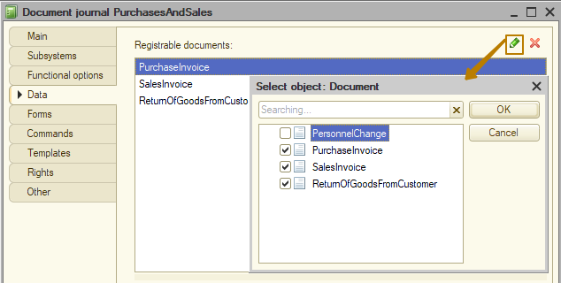
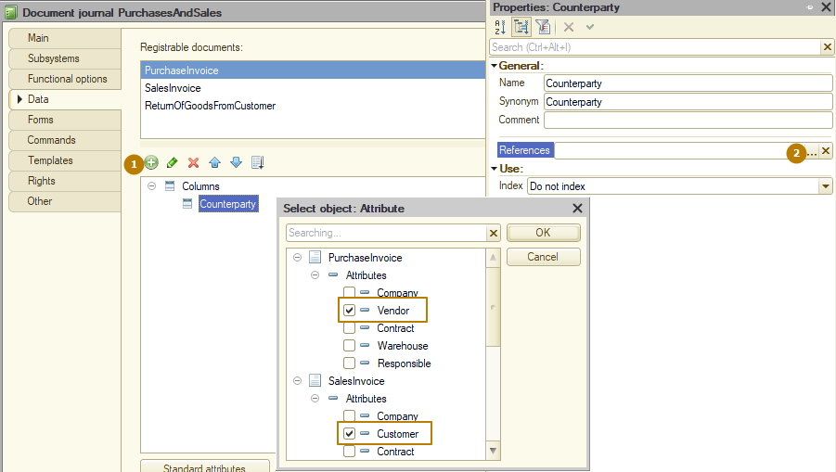
Note: You cannot select multiple attributes of the same document into one journal column.

The result:
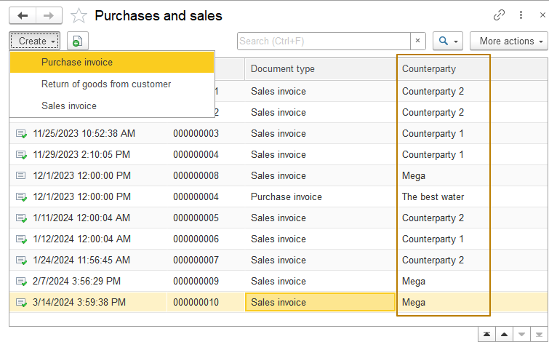
You can see that in addition to the Contractor column I added, the journal also contains default columns: date, number, document type. You can add any number of additional columns to the journal.
If the details of a document are not selected, then this column of the document journal will not contain information on all documents of this type. When choosing, you should be guided by common sense and not mix completely different concepts in one column (for example, a counterparty and the total amount of the document).
Also, if the number of documents included in the journal is more than 1, the button for creating a new document turns into a submenu with buttons for selecting the type of document to be created:
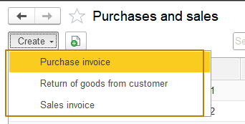
For each journal, the system creates a table in the database that stores links to documents of those types that are included in the journal, and also duplicates the content of documents included in the columns of the journal, document numbers, marks of posting, etc. When a document is written to the database, the system makes records in the tables of the journals to which the document belongs or updates document records that already exist there.
Charts of characteristic types
When developing applications, you often need to organize the storage of certain properties of applied objects, the composition and type of which is not known in advance (at the application development stage).
Examples of such properties:
- For products these can be characteristics of color, size (of clothing or shoes), dimensions (length, height, width), packaging material (glass, plastic), etc.
- For the counterparty, the list of characteristics is completely different, for example, these may include the characteristics “foreign company”, “settlement in foreign currency”, etc.
- Warehouses have their own characteristics, for example, “requires an order for a pass to the territory”…
When developing, the content and type of data stored are not specified for such properties (hereinafter characteristics). It is also possible that the list of such characteristics will be quite large and each application user will have to operate it.
Please note that the characteristics can be different for various objects groups. For example, for one product group, you can specify color and size. While for other, only dimensions are used. Note that users can enter characteristics themselves during the operation. There are two ways to do this:
- A separate attribute of the required type is created for each characteristic in the relevant object. This way has several disadvantages:
- Each characteristic is a separate field in the database table, which will take up space in the database no matter whether the characteristic is used.
- When there are a lot of characteristics, there will be a lot of "redundant" fields. It will not be convenient for both the developer and the user to operate with them.
- If you need to add a new characteristic, you will have to customize the application: add a new attribute and consider it everywhere in the application. This requires a lot of effort and is inconvenient.
- Using the special objects, which describe characteristic name, type and so on. This model does not have the disadvantages of the previous one. To add a new characteristic, you do not have to change the application. It also does not require extra space in the database. The user can also add the new object characteristics. The 1C:Enterprise provides such object. It is called a chart of characteristic types.
However, there are some disadvantages. The characteristic organization and usage logic is more complex. However, the costs associated with the complication of the application will be incurred only once - during the development of the application. While the number of characteristics and types increases, the additional customization of an application is not required.
In order for the developer to specify a set of possible value types that characteristic types can take, the Chart of characteristic types configuration object has the "Characteristic value type" property.
This property defines a composite data type that includes all the types that might be needed when specifying the type of a characteristic's value.
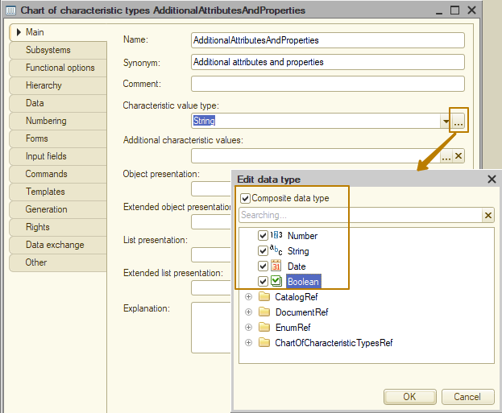
In addition to using primitive types as characteristics, it is often necessary to use references to objects in the database as characteristics; for example, a “Main supplier” characteristic with a link to a counterparty can be created for a product. There is also a need to maintain data integrity; for this purpose the use of primitive types, as well as existing objects of configuration, is not suitable. For example, for a group of products of the type clothing and/or shoes, the “Color” characteristic was created, but if you allow to enter color as a string, a user will be able to specify duplicate values for a single meaning (red, Red, Redd).
You should not always give the user the opportunity to enter an arbitrary value; sometimes you should limit his choice to a certain list of values, for example, for a certain pair of shoes, only the sizes that actually exist for such a model should be available.
For such cases, it is possible to store additional characteristic values in a separate object: the developer must create a special catalog subordinated to a chart of characteristic types and specify it as the value of the “Additional characteristic values” property of the Chart of characteristic types configuration object.
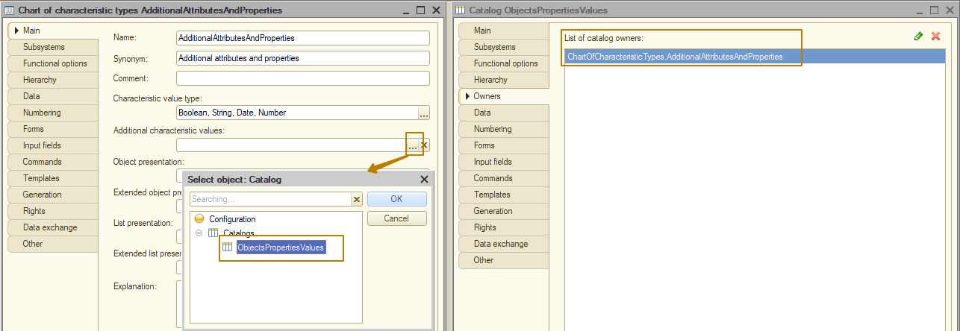
Note: in order to select a catalog as the value of the "Additional characteristic values" property, it must also be selected in the property "Characteristic value type".
Then the user, having created a new type of characteristic “Color”, will be able to specify the necessary color values in the catalog of object properties values.
So, I created a chart of characteristic types, as well as a catalog for storing additional values of the characteristics. But I am missing an object that will store the values of characteristics linked to the owners (product, counterparty, etc.). The information register is best suited for these purposes.
I will create such a register with the name “ObjectsCharacteristicValues”, the dimensions will be “Object” (this is the owner of the characteristic), “Characteristic type” (a link to the chart of characteristic types), and a resource is “Characteristic value”. In the list of Object dimension types, I indicate all the objects that I want to connect to the mechanism of additional attributes (characteristics).
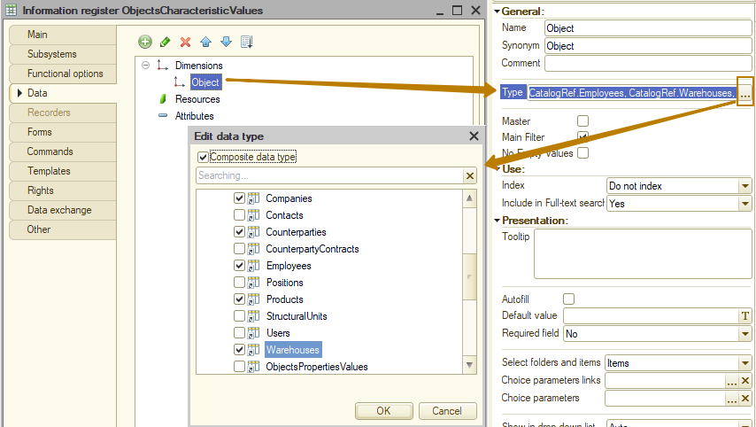
Let's enable the "Master" and "No empty values" flags (we previously studied the purpose of these flags in the topic about information registers) for both dimensions.
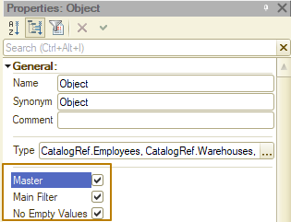
Pay attention to the resource "Characteristic value" value type: after the chart of characteristic types was added to the configuration, the "Characteristic" group appeared in the list of types, in which chart of characteristic types whose characteristics can be specified as value types are available as a type. I choose the characteristics of my new object
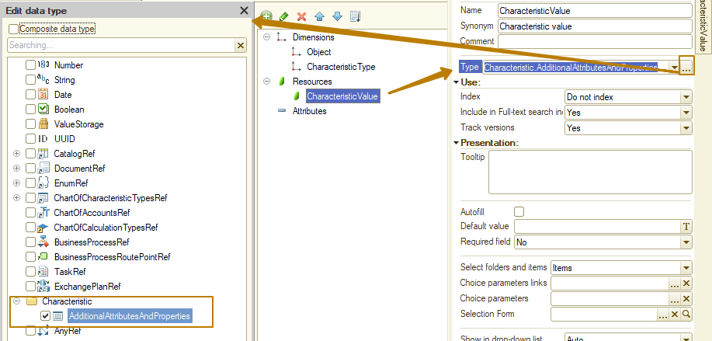
Note: it is impossible to specify for this resource a composite type consisting of several Characteristic types, this means that the values for one chart of characteristic types can be stored in one register (for the second chart of characteristic types - in the second register, etc.).
After making the changes, I update the database configuration and test the result in Enterprise mode. I open the form of the "Scissors" product, go to the "Objects characteristics values" tab
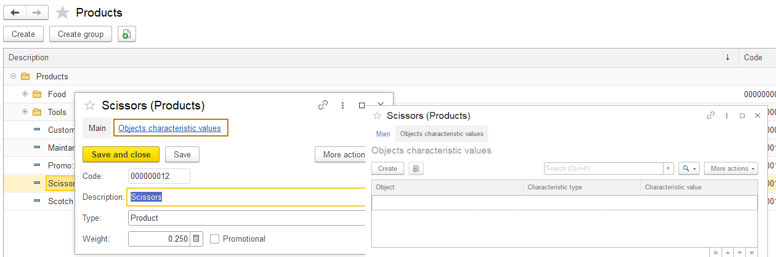
Next, I create a new characteristic value using the “Create” button, select the characteristic type “Color” and begin selecting the characteristic value
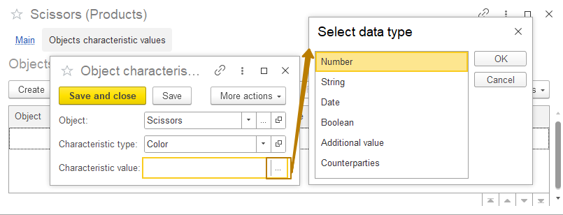
The type selection form opens, which means that, although I selected the “Color” characteristic type, which has a single type of value, the “Characteristic value” field does not know about it. I have to make changes to the configuration so that the type automatically changes when selecting a characteristic type.
The resource CharacteristicValue has a property "Select type automatically", I should set the value "Characteristic type" in this property by selecting it from the list that opens in order to configure the dependence of the type of this field on the value of another field (CharacteristicType dimension).
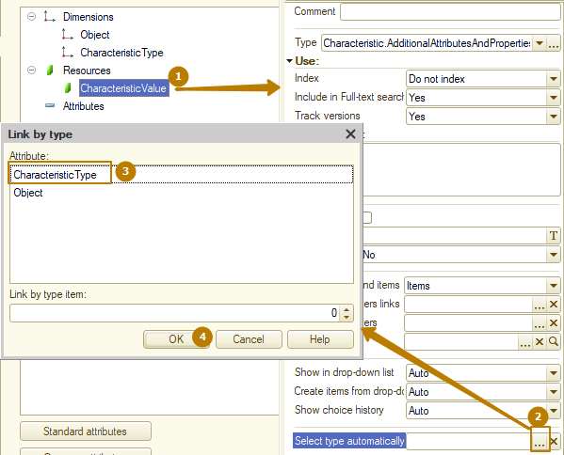
You can see that now I don’t see the type selection button (the button with three dots), but I immediately see the select from the list and open buttons, which indicates that the value of this field has a value type defined.
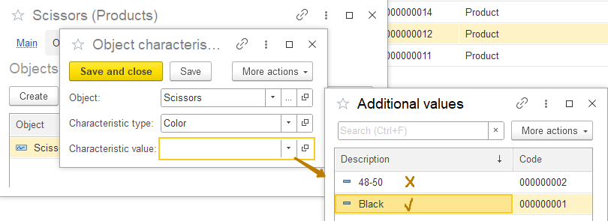
The next problem is that I see all the additional values, and not just those that relate to the selected type of characteristic. The value "48-50" refers to the "Size" characteristic type and should not be displayed when selecting values for the "Color" characteristic type. In order to filter the list when selecting additional values, we need to set the parameters for selecting values in it for the information register resource
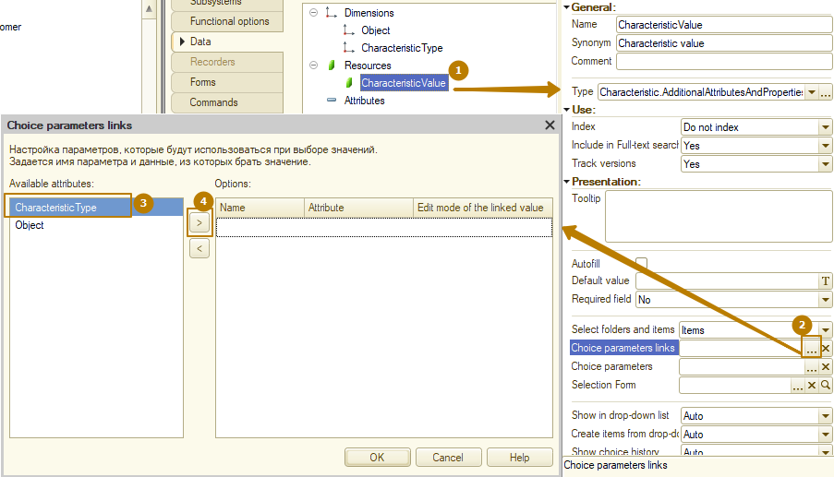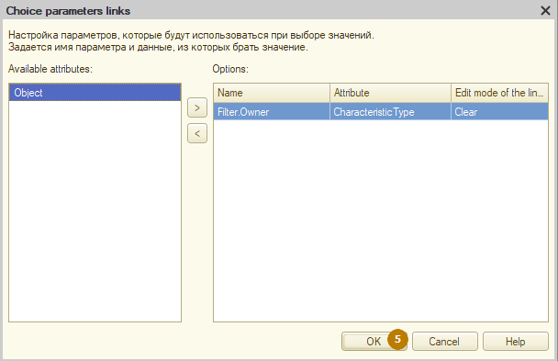
I update the configuration and check the result
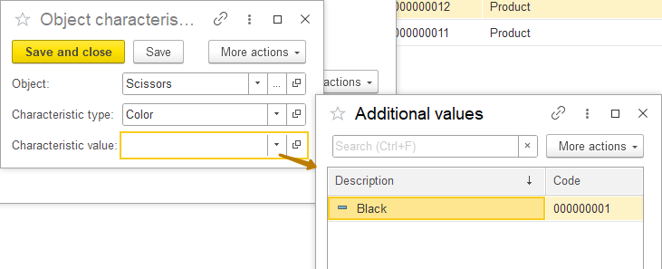
Now the list contains only values related to the selected characteristic type.
The next step that I need to perform is dividing the types of characteristics into belonging to certain objects. Since my chart of characteristic types serves several objects (Products catalog, Counterparties catalog, Warehouses catalog, etc.), I want that when creating a new characteristic value, for example, for a product, I would see only the characteristic types related to the product. Otherwise, the user of the system will have the opportunity to specify the color for the counterparty, which is incorrect.
In order to implement this behavior of the system, I must first create an enumeration of CharacteristicsObjectTypes containing values that describe the owners of the characteristic types, in my case these are Companies, Counterparties, Employees, Products, Warehouses. I also assign more detailed synonyms to values.
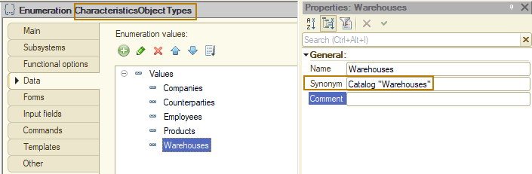
Next, I must add the CharacteristicsObjectType attribute to my chart of characteristic types and specify the newly created enumeration as the type. The attribute should be made required to fill.
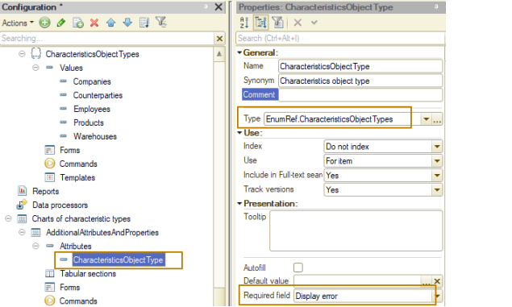
Now I should add 2 modifications to the record form of the information register “Objects characteristic values”:
- Hide the object for which data is being filled in from the form. For example, if a user creates a new register entry for the item “Scissors,” then this field should not be displayed on the form, much less be given the opportunity to change this item to another in the current register entry.
- Set choice parameters links for the "CharacteristicType" field according to the characteristic object type, if the form is open for a specific item or if the item has been changed on the form.
To implement the first modification, I created a record form for the register, in the form module I created an event handler for the OnCreateAtServer event, in which I wrote the following code: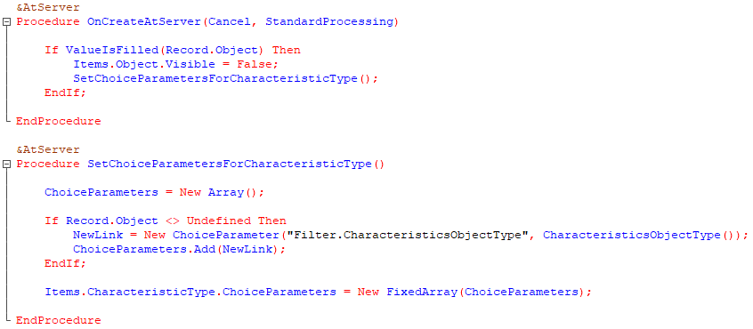
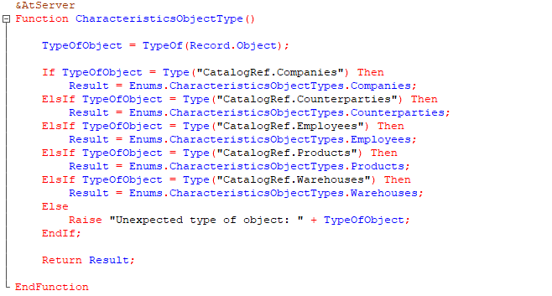
Let's figure out what this code does. When creating a form, we check whether the object is filled in. If the form is opened for a specific product (or company, warehouse, another object) or it is creating a new record by copying an existing one, the Object dimension is already filled in, in this case we hide the Object field from the form, otherwise we display it and then the user fills it.
This form was opened from the product form:
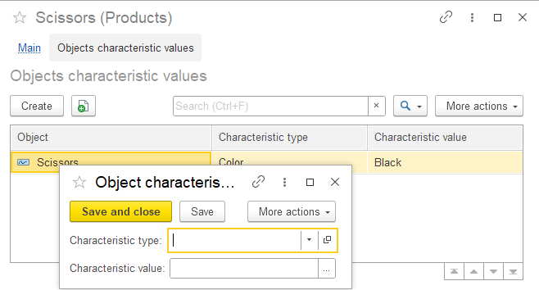
And this form was opened from the register list form:
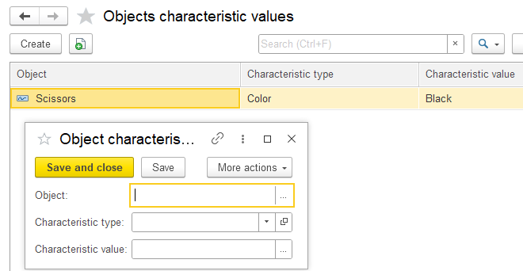
Also, for the case when the Object is already filled, a procedure is called in which, for the CharacteristicType field, the choice parameters are set according to the CharacteristicsObjectType attribute of the chart of characteristic types. If the value of an object is not equal to Undefined, then at least a type has already been selected for the object, then the choice parameters take this type into account - thus, a selection is set for the reference to the product so that the user can select the type of characteristic only with the sign of belonging to the Products catalog. If the object is not filled, empty choice parameters are set, i.e. there are no filters.
You should also add a call to this procedure for the OnChange event of the Object field, so that when changing one type of object to another, clear the value of the CharacteristicType and CharacteristicValue fields, as well as update the choice parameters of the CharacteristicType field.
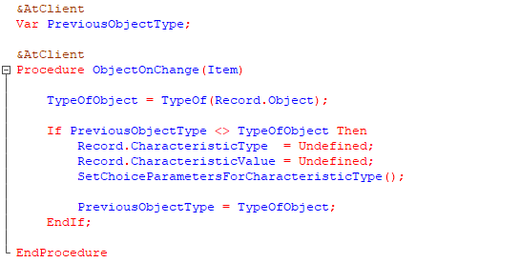
The PreviousObjectType variable retains the type of the object when the value in the Object field changes. In the OnChange event handler of the Object field, it is checked whether the type stored in the variable is different from the current one. If yes, then the fields are cleared and the selection procedure is called. The last step is to update the value of the variable.
Now I should “explain” to the system how to select types of characteristics for a particular metadata object (this must be done for each object that has characteristics):
● In which object the list of characteristics is located.
● Which key field will be used to obtain a specific characteristic to determine the type of value (type of characteristic) and presentation of the characteristic.
● By which characteristic attribute (and with what valueof filter) the list of characteristics associated with a specific metadata object will be determined.
This should be done using the Additional metadata object characteristics window, which can be called from the context menu of the metadata object (Characteristics row) or by clicking the Characteristics button on the data tab of the object editor
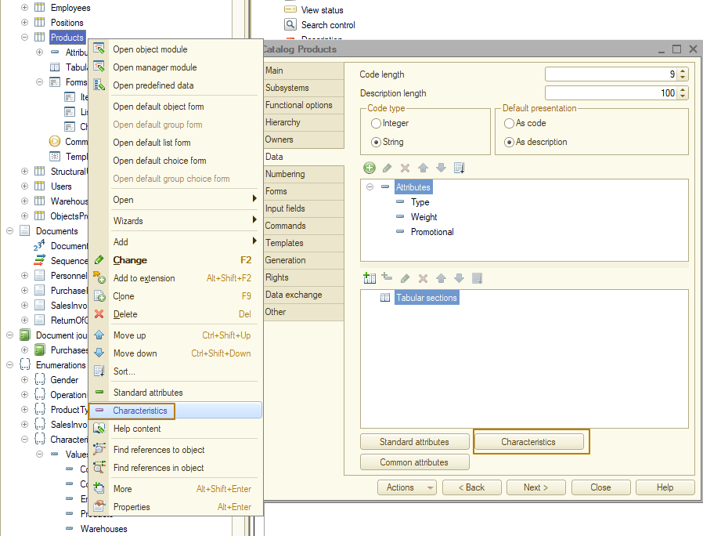
The following is an example of specifying rules for selecting characteristics for the Products catalog.
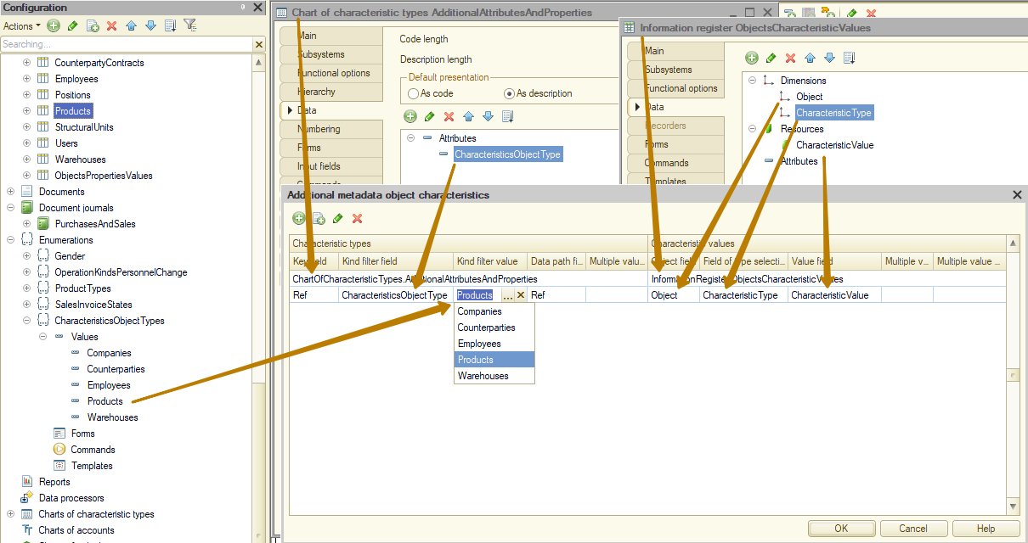
The “Additional metadata object characteristics” window describes which object provides types of characteristics and how (the left part of the window) and where the characteristic values are stored (the right part of the window). In this example:
● Characteristic types are located in the AdditionalAttributesAndProperties chart of characteristic types (Characteristic types field).
● The characteristic type and its representation will be obtained from the characteristic type plan element. Standard attribute of the characteristic type plan The ref will act as a key field (Key Field property) for searching for the required element of the chart of characteristic types.
The storage description will be used by the system in cases where it is necessary to obtain a list of characteristic values for a metadata object. That is, thanks to the settings of the characteristics of a metadata object, a user can access its characteristics as attributes in any report and dynamic list. For example, in the list form of the Product catalog, I can configure filter by characteristic value, and only characteristics that satisfy the settings will be available for selection; for the product in my configuration, these are the characteristics Color and Size:
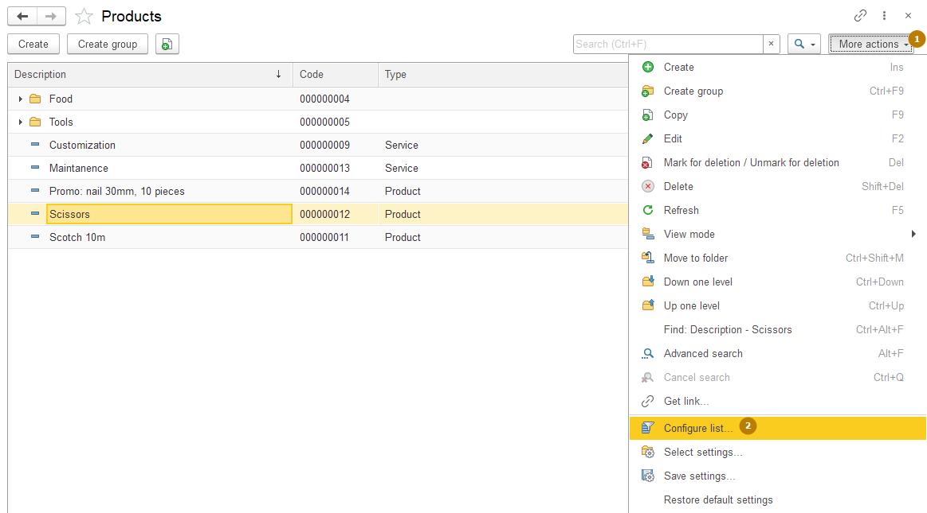
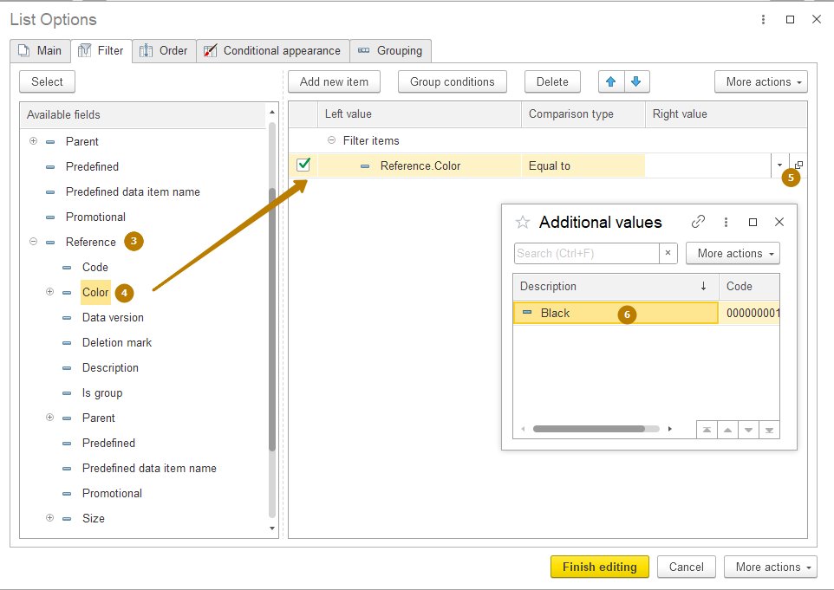
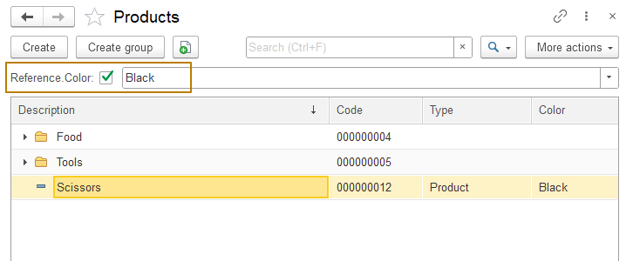

In order to consolidate the information, I repeat: such a setting must be made for each metadata object with characteristics. Therefore, I repeat this procedure for the Companies, Counterparties, Employees and Warehouses catalogs:
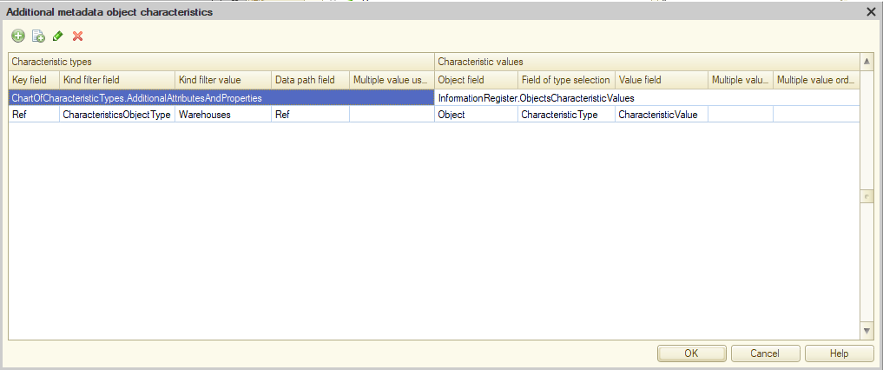
Let me note that this is just one of many options for using a chart of characteristic types, when many objects use a single plan of characteristic types. In fact, there may be other options:
- One chart of characteristics types for one metadata object.
- One chart of characteristics types for one (or several) metadata object, but the availability of certain characteristics is configured separately for elements/groups. For example, for products in the “Shoes” group, the “Shoe Size” characteristic is used, while for products outside this group, it is useless.
- One plan of characteristics types for several metadata objects, but the characteristics do not belong to the object directly, but through an intermediate entity.
As an example of the second option, we can imagine that we would like to be able to specify a certain set of characteristics for many product items. Thus, the set of characteristics “aluminum can, 330 ml” can be specified for many products of different brands. In this case, the characteristics will be stored in a separate catalog CharacteristicSet, which in turn can be selected in conjunction with a product. The advantage of this approach is that we can keep records in terms of characteristics (i.e. registers reflecting purchases, sales, etc., contain information about the nomenclature + set of characteristics), in contrast to the approach that I analyzed for demonstration - there, each characteristic is a separate value of the object. That is, if I want to find out the remains of goods with the characteristics “aluminum can” and “330 ml”, I will need to impose two selections and combine them into the “I” group.

Using characteristics in queries during development
As the last step, I propose to look at an example of creating a query that selects data by products with displaying characteristics in separate fields (each characteristic in a separate field/column).
For example, I need to select an item from the "Clothes and shoes" group and display color and size in separate columns.
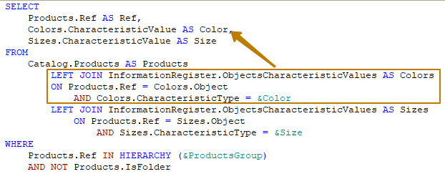
You can see that in order to display the value of the Color and Size characteristics in separate columns, I connect to the register table that stores the values of the characteristics twice and in the join condition I indicate that I am interested in a specific type of characteristic, as well as the fact that the value characteristics must be obtained for specific items of the product; for this, the join condition checks the equality of the object from the register and the reference to the product.
In the WHERE section, in addition to the checking of the product into the group hierarchy, I also indicate that the query result should not contain groups (folders).

